Name ___________________________ Date ____________________

Directions: Name the picture. Circle its name.

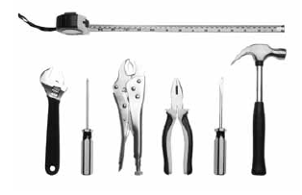  school tools  cool pool | 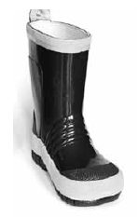  boot  hoot  loot  root | 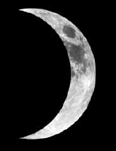  soon  noon  boon  moon
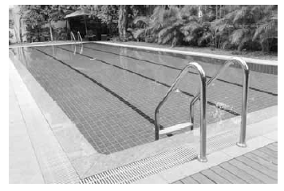  pool stool  cool spool | 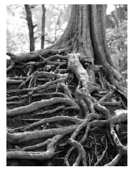  hoot  loot  toot  roots |   roof  booth  tooth  poof
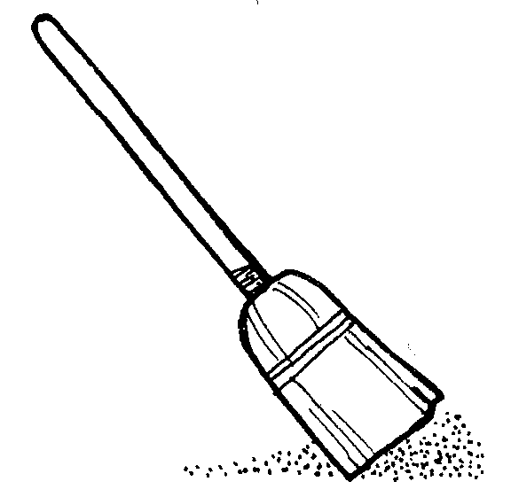  broom  room  zoom  doom | 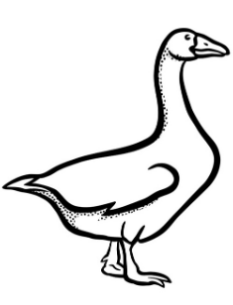  moose  loose  goose  hose |   cool  pool  school  tool
loom zoom  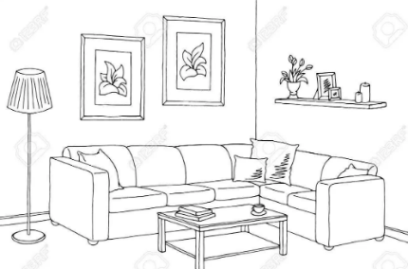  doom room |   loop  hoop  scoop  droop | 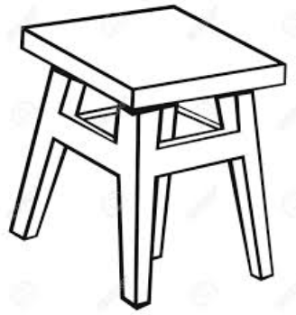  tool  pool  stool  cool

